Food, Drink & Franchising Special Report – FDF World

Hey ,

Just touching base to see if you would be interested to discuss the potential of becoming one of our ‘Food & Drink Franchise Showcases’ for the next editions of our Business Review Asia and FDF World magazines.

As you can see, we’ve worked closely with a lot of your associates below, and we’d like to produce the same format for you and your region.

We are running a series of feature articles called 'The Journey to Brand Transformation & Digital Disruption' and have been focusing on the following areas:

● Brand Transformations

● Digital Disruption Initiatives

● Vendor Management Strategies

● Cloud Computing & Big Data

● AI / Machine Learning

 I think you could potentially be a perfect fit to be featured in the January issue and I would welcome the opportunity to discuss further. Below are the latest editions of the magazines and a couple of interesting recent ‘Digital Assets’ - (click front covers below to view):

[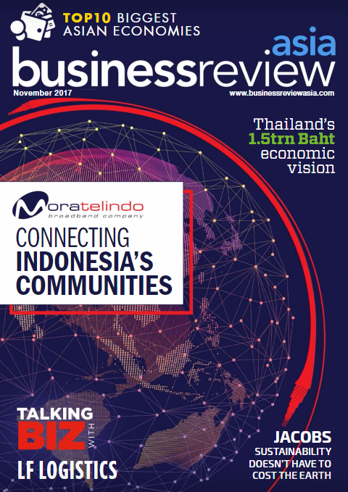](http://businessreviewasia.com/magazine/issue?id=26716553/54614179) [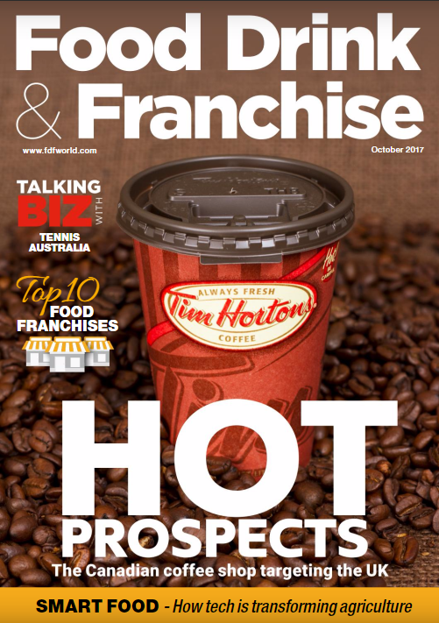](http://www.fdfworld.com/magazine/fdfworld-october-2017) [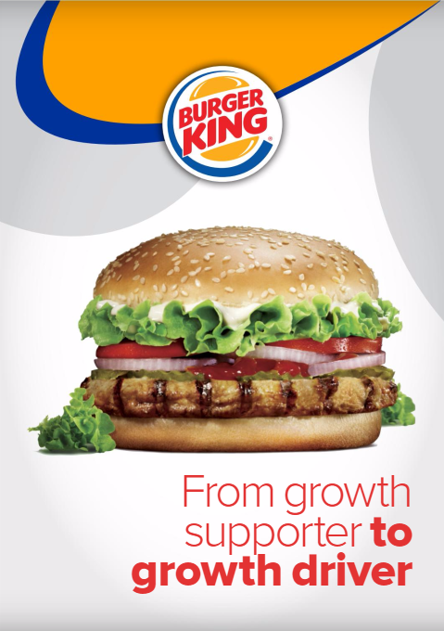](http://businessreviewasia.com/company/15/brochure/12457835/38424825) [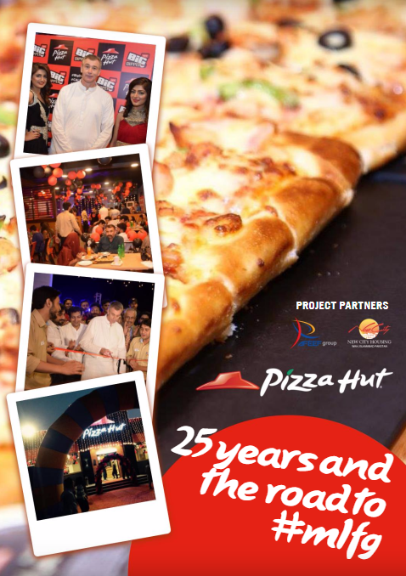](http://businessreviewasia.com/company/36/brochure/12613397/46835001) [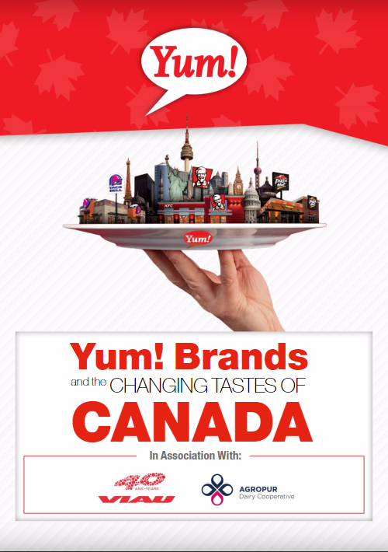](http://www.businessreviewcanada.ca/company/302/brochure/12486628/52757125)

Let me know if this is of interest as I would like to try and set up a call in the next few days?